Charity Pot Difficulty: 1/5 Students in year 7 have been collecting money for charity.
- Create a program that allows the user enter the total for each form group.
- The program should calculate the total overall for the 7 form groups.
- It should also output the average amount collected by the forms

Riddle Difficulty: 2/5
Create a program that allows the user to solve a riddle.
After 3 incorrect attempts, the user should be given a clue.
After 3 further attempts, the solution should be explained.

Authentication Difficulty: 2/5
Create a program that allows the user to enter their username and password.

The following accounts should be accepted:
Username | Password
20AB01 | Jug52!fD
20CD02 | D68aWEf$
20EF03 | 15Dcs56!s
20HI04 | kyGTy53q4

Allow 3 attempts before locking the user out.
Password Checker Difficulty: 2/5
Allow the user to enter a password:
Check that the password has:
- at least 6 characters
- at least 1 uppercase character
- at least 1 lowercase character
- at least 1 number
- at least one symbol
Output an appropriate message to tell the user how strong their password is and how it can be improved

Extension
Require the user to keep entering their password until they have met all the criteria

Judging Panel Difficulty 2/5
Create a program that will allow the user to input 6 scores.
- The program should dismiss the highest and lowest scores
- It should find the average of the other 4 scores

Extension
Amend the program so that the user can adjust the number of scores to be entered.

Primary School Revision Difficulty 2/5
Use subroutines to create a program to do the following:
- It should ask the user which they would like to do: spellings or maths.
- If they choose spellings, it should ask them to choose the correct spellings of tricky words.
- If they choose maths, it should ask them to perform simple maths calculations.
  - The numbers used in the maths questions should be chosen at random.
- The program should output a score based on the number questions they answer correctly.

Extension
Allow the user to choose a difficulty level and provide questions based on the difficulty level.

Student Scores Difficulty: 2/5

Part 1
Create a program that accepts the input of 10 student test scores, and outputs the average of these scores. Your program should validate the student scores which must all be whole numbers between 0 and 10 inclusive.

Part 2
Amend your program to allow the input of an unlimited number of student scores, outputting the average, highest and lowest score.

You will need to include a way of stopping the input of scores so that the program will then calculate the output. This could be done by entering a value of 'x' or -1 instead of a student score. An example of output is shown below.
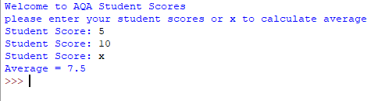

Part 3
Amend your program to include the input of the student first name as well as their score. Output the name and score of the student with the highest score, the name and score of the student with the lowest score, and the average score.

Part 4
- Use a record structure to save, search and output student scores. A linear search, binary search (with sort) could be used to demonstrate these techniques.
- Add a menu to your program that will allow the user to select functions such as searching, calculating the mode, and median of a set of student scores etc.

Santa’s Naughty List Difficulty: 2/5

Brief: You need to create a program to store Santa’s Naughty List.

The program must contain a list of 5 children to begin with. It should have a menu so that Santa can choose one of the following options:
- Add a new child
- Remove a child
- Display the current list (with one name on each line)
- Check if a child is on the list
- Quit the program
Santa should return to the main menu once he has completed an option.

Extension:
- Add a nice list.
- Allow an option for Santa to transfer children between the lists
- Allow the Santa to search both lists to see which list someone is on.

Code Breaker Difficulty: 3/5

Brief: Create a puzzle game where the computer generates a random code containing a number of digits. The user must guess the code using a limited number of tries. The computer tells them how many digits they guessed correctly.

Your software must do the following:
- The computer generates a 4 digit code
- The user types in a 4 digit code.
- The computer tells them how many digits they guessed correctly.
- The user should have 10 guesses to attempt to find the answer

Extension:
- Edit the program so that the user can choose a level of difficulty. The number of digits in the code should be appropriate for the difficulty level (e.g. Easy might have 3 digits)

Higher or Lower Difficulty: 3/5

Brief: Write a program that will generate a random playing card e.g. ‘9 Hearts’, ‘Queen Spades’. The user should be asked to guess higher or lower before a new playing card is generated. If the user guesses correctly, a new card is generated. They need to guess 5 correctly to win.

Your software must do the following:
- Include a starting screen that explains the game
- Rather than generate a random number from 1 to 52, create two random numbers – one for the suit and one for the card.
Extension:
- Include ASCII art for each suit (Hearts, Spades, Diamonds, Clubs)
- We don't want the same card drawn twice. Update this program by using an array to prevent the same card being dealt twice from the pack of cards.

Vending Machine Difficulty: 3/5

Brief: A national train company have decided to introduce a vending machine on their long-distance trains for ‘technology essentials’. You have been asked to program the software for their prototype system.

Your software must do the following:
- Allow the user to enter codes to choose items
- Output the name and display the price of each item
- When they are finished choosing items, the total due should be displayed.
- Allow the user to enter a cash amount
- Calculate and display the amount of change due
- Begin the process again for the next customer

Code | Item | Price
A1 | Earphones | £9.99
A2 | Micro USB Charger | £7.50
A3 | iPhone Charger | £9.50
B1 | Micro SD Card | £6.75
B2 | 24 Hour Wi-Fi Code | £3.50
Items:

Extension:
- Maintain current stock levels for each item
- Advise the customer if an item is out of stock

Super Challenge
- Allow the owner to restock items
- Calculate the individual coins required for the customers change

Planets Game Difficulty: 3/5
Brief: You have been asked to create a game for primary school students to learn the order of the planets in the solar system.

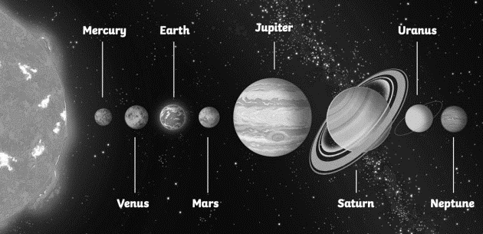
Your software must do the following:
- The game should include the following type of questions:
- Which planet is in position 3? (the position should be random)
- What position is planet Neptune? (the planet should be random)

- Add the following type of questions:
- Which planet is after planet Saturn? (the planet should be random)
- Which planet is after planet Jupiter? (the planet should be random)

- The game should use iteration to ensure the user is given 12 questions

- The questions should be given in a random order

- The game should maintain a scoring system and a suitable message should be output based on the final percentage score.

- The game should allow the user to enter their name and keep a record of the highest score. The highest score should be displayed at the beginning of the game.
Wordle Difficulty: 3/5
Brief: Create a simulation of the popular online game Wordle.
- You should include a list of 5 letter words. Each time the game is played, one should be chosen at random.
- The user should have 6 opportunities to guess the word.
- If their guess included a correct letter, this should be highlighted.
- If their guess includes a correct letter in the correct space, that should be highlighted.
- If they guess correctly, they should be notified that they have won.
- If they run out of guesses, they should be notified that they have lost.
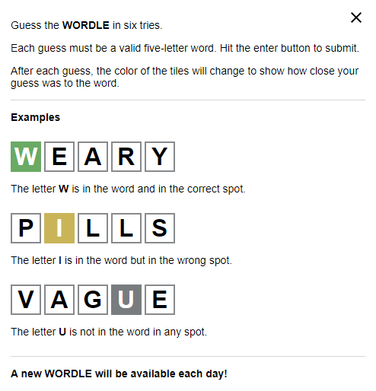
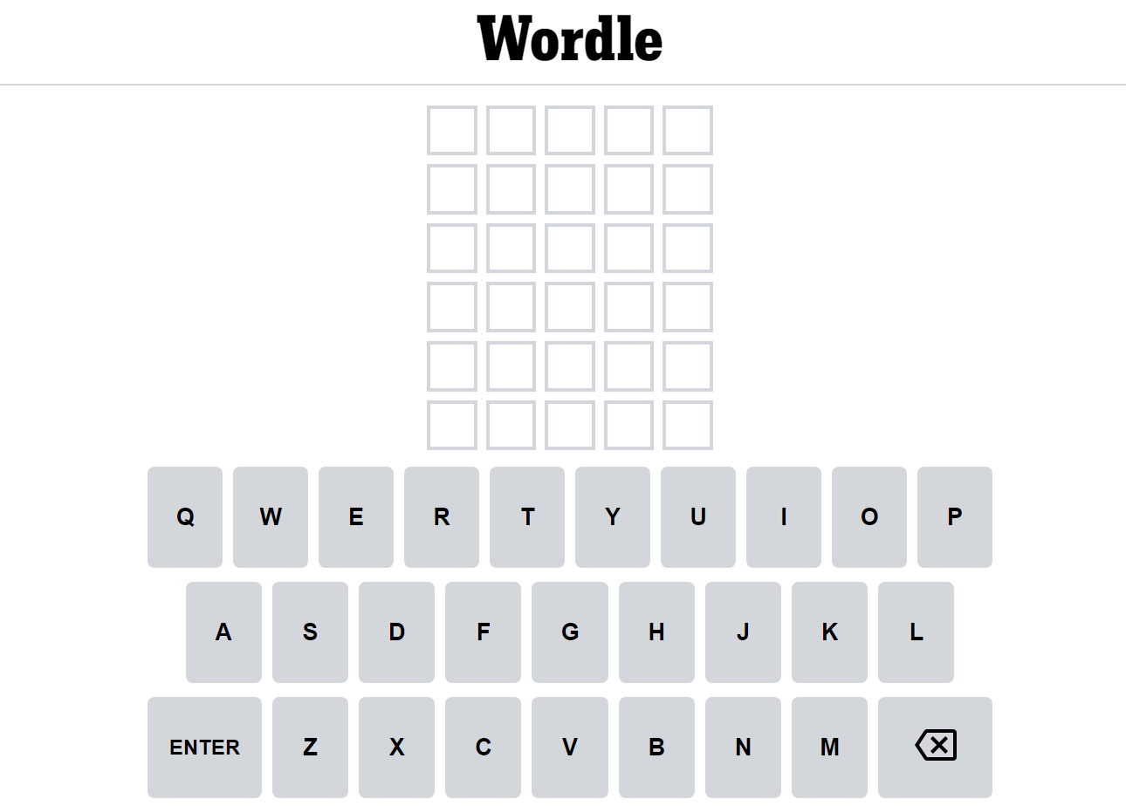

User Registration Difficulty: 3/5

Part 1: The program is intended to allow a user to register a new account by entering a username and password.
- If the username has been used before then an error message is shown, and the program ends.
- If the username has not been used before then the password is checked to make sure that it is at least 12 characters long.
- If the password is too short the program ends.
- If the username and password are valid then they are displayed to the user with a success message.

Enhance the Python code in Figure 1 so that it meets the brief above and works correctly.

Figure 1

userNames = ["User1", "User2", "User3", "User4", "User5"] print("Welcome to AQA User Registration")
userName = input("New username: ")

userPassword = input("Password (12 characters or more): ")

Part 2: Amend your code so that it meets the following requirements:
- Add comments so the code is self-documenting
- When checking the username, the program should treat upper case letters and lower case letters as being the same. eg User1 is the same as user1
- The user is allowed 3 tries to enter a username that has not already been used, before the program ends
- The user is allowed 3 tries to enter a password that is at least 12 characters long before the program ends.

Part 3: Amend the program so that it is a fully functioning user registration system.
- Add a menu to the program, so that the user can choose between entering and validating an existing username and password, registering a new username and password, or quitting the program.
- Use file(s) to store username / password combinations.
- You should use modular code in your program.
- The program output might look like the output in Figure 3.
Figure 3
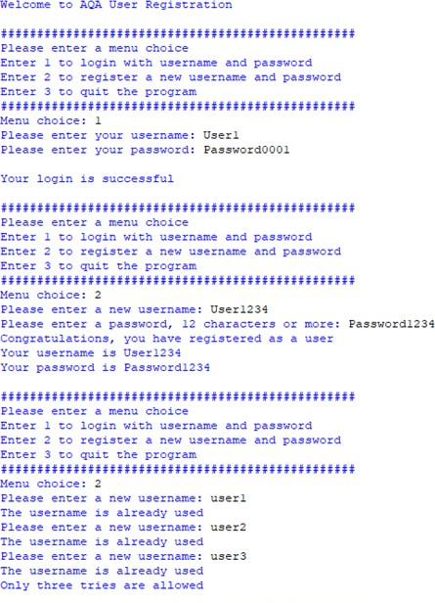
Caesar Cipher Difficulty: 3/5
Brief: Caesar cipher is one of the simplest and most widely known encryption techniques. It is a type of substitution cipher in which each letter in the plaintext is replaced by a letter some fixed number of positions down the alphabet. For example, with a left shift of 3, D would be replaced by A, E would become B, and so on. The method is named after Julius Caesar, who used it in his private correspondence
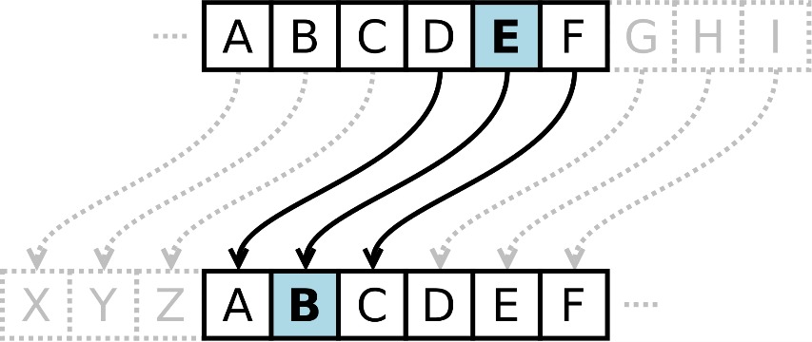

Your application must do the following:
- Allow the user to enter a word or phrase
- Allow the user to choose how many positions they would like to change the plan text by
- Perform the encryption and output the answer
Extension:
- Include an option to decrypt messages

Betty’s Bakery Difficulty: 4/5
Brief: A new business has opened in your local area that provides materials and ingredients for home bakers to create cakes and other baked items in their own kitchens.
The owner has decided to extend the business by allowing customers to purchase cake kits over the Internet. Customers will be able to select the items they wish to make and the owner will send them all the basic ingredients that they will need.
To make sure that the business runs efficiently the owner needs a system to work out the basic ingredients for each of the recipes chosen and calculate the total of each basic ingredient needed.
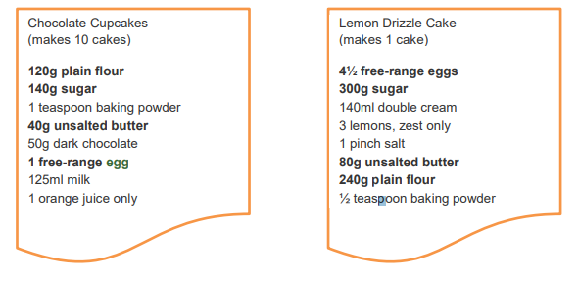
The owner will not have time to weigh out these ingredients individually and therefore wants to send out bags of each ingredient. The bakery has a range of bag sizes for the standard ingredients such as sugar and flour. Sometimes customers will want to make more cakes, for example, 2 drizzle cakes or 15 cupcakes.
Basic Ingredient | Small | Medium | Large
Plain flour | 250 grams | 500 grams | 750 grams
Sugar | 200 grams | 400 grams | 600 grams
Unsalted butter | 125 grams | 250 grams | 500 grams
Free-range eggs | Box of 6 eggs | Box of 10 eggs | Box of 12 eggs
The owner wants you to write an application that will:
- Input a customer’s order which may include ingredients for more than one recipe
- Calculate and display the total quantity for each ingredient
- Calculate the fewest required number of bags and boxes of each basic ingredient
- Produce and display a list of all bags and boxes of each basic ingredient to be sent to a customer
Battleships Difficulty: 4/5
Brief: Battleship is a strategy type guessing game played on ruled grids on which each player's fleet of warships are marked. The locations of the fleets are concealed from the other player. Players alternate turns calling "shots" at the other player's ships, and the objective of the game is to destroy the opposing player's fleet. Please research Battleships before beginning this task. You must create a simple 1 player version of the game.
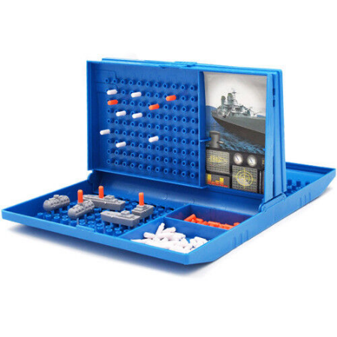

Your software must do the following:
- Create a 10 by 10 list to represent the grid.
- Randomly choose 8 of the locations in the list to be ships
- Display the grid without revealing the 8 locations and allow the user to choose which column and row they would like to ‘shoot’. (e.g. 27 could represent row 2 and column 7)
- Allow the user 20 attempts to ‘hit’ the ships
- Reveal to the user if they have ‘hit’ a ship after each ‘shot’
- At the end, reveal whether they have been successful
The School Council Difficulty: 4/5
Your head teacher has asked you to create an application that will be used to determine the winner of the election for new members of the School Council.
Each year group must elect one person to sit on the School Council. Pupils must complete the ballot slip for their year group. They must rank the candidates in order of preference, with 1 indicating their favourite choice and 5 their least favourite.
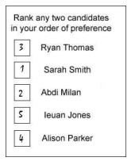
The head teacher has decided that candidates will be awarded points reflecting the value of their preference votes, for example, the ballot paper above will give Ryan Thomas 3 points and Sarah Smith 1 point.
- For each candidate, the points from all ballot papers will be added together
- The candidate with the lowest total points will be declared the winner
- In the event of a tie, where one or more candidates have the same number of total
- points, then the tied candidate with the most first preference votes will be the winner

Your task is to write an application that will:
- Input the names of the candidates standing for the School Council election
- Input the preference votes from the ballot papers
- Display all the candidates and their total number of points
- In the event of a tie, use the preference votes to identify the winner
- Display the outcome of the election
Car Database Difficulty: 5/5
Brief: A car showroom needs to store details about their stock. The owner has used a list to store the data.
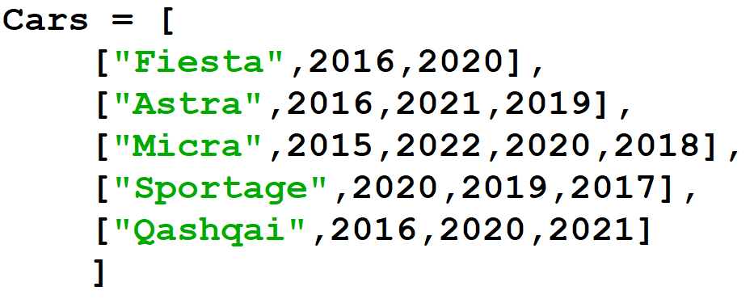
Create a program including the following:
- A menu that allows the user to choose the following options: Display cars, Find by Model, Find by year, Add Car, Remove Car, Quit.

- If the user chooses ‘Display cars,’ each of the cars should be listed in the format:
2016 Fiesta
2020 Fiesta
2016 Astra
2021 Astra
2019 Astra

- If the user chooses ‘Find by Model’ they should be able to search for a particular model. If the model is available, the years should be displayed.

- If the user chooses ‘Find by year,’ they should be able to search for a year. If the year is available, the models should be displayed.

- If the user chooses ‘Add car,’ they should be able to add a new car.

- If the user chooses ‘Remove car,’ they should be able to remove a car.

- If the user chooses ‘Quit,’ a suitable message should be displayed and the program should end.

Flight Planning Difficulty: 5/5
Brief: A new airline wants to start running commercial passenger flights. In order to assess the feasibility of proposed flights they want a program that can help them calculate the likely profitability of running a flight between a UK airport and an overseas airport. The UK airport will be either Liverpool John Lennon or Bournemouth International.

The following details have been provided: the name and code for each overseas airport, the distance from Liverpool John Lennon airport and the distance from Bournemouth International airport.

Overseas airport code | Overseas airport name | Distance from  Liverpool John  Lennon (km) | Distance from  Bournemouth  International (km)
JFK | John F Kennedy International | 5326 | 5486
ORY | Paris-Orly | 629 | 379
MAD | Adolfo Suarez Madrid Barajas | 1428 | 1151
AMS | Amsterdam Schiphol | 526 | 489
CAI | Cairo International | 3779 | 3584

When the program is used, the following details will need to be entered:
- UK airport
- overseas airport
- type of aircraft
- number of first-class seats
- price of a first-class seat
- price of a standard-class seat.
The airline owns three types of aircraft. The details are provided below.
Type | Running cost  per seat per  100 km | Maximum flight  range (km) | Capacity if all  seats are  standard-class | Minimum  number of firstclass seats (if  there are any)
Medium narrow body | £8 | 2650 | 180 | 8
Large narrow body | £7 | 5600 | 220 | 10
Medium wide body | £5 | 4050 | 406 | 14

From the details provided by the user, the program will calculate the potential profit or loss of running the proposed flight assuming it is at maximum capacity. Each first-class seat takes up space for two standard-class seats.

Calculations
Number of standard class seats | Capacity if all seats are standard-class – Number of first-class seats x 2
Flight cost per seat | running cost per seat per 100 km (for the selected type of aircraft) ×  distance between the UK airport and the overseas airport / 100
Flight cost | flight cost per seat × (number of first-class seats + number of standardclass seats)
Flight income | number of first-class seats × price of a first-class seat + number of  standard-class seats × price of a standard-class seat
Flight profit | flight income - flight cost

Example
UK airport | Liverpool John Lennon
Overseas airport | John F Kennedy International
Distance | 5326 kilometres
Type of aircraft | Large narrow body
Maximum flight range | 5600 kilometres
Running cost per seat per 100 kilometres | £7
Capacity if all seats are standard-class | 220
Number of first-class seats | 40
Number of standard-class seats: 220 - 40 × 2 | 140
Price of a standard-class seat | £400
Price of a first-class seat | £1200
Flight cost per seat: 7 × 5326/100 | £372.82
Flight cost: 372.82 × (140 + 40) | £67,107.60
Flight income: 140 × 400 + 40 × 1200 | £56 000 + £48 000 = £104 000
Flight profit: 104 000 - 67 107.6 | £36 892.40

The user will also have the option to clear all the data they have entered and start again.

The program should work in the following way:
1. A menu should be displayed allowing the user to select from the following options:
- Enter airport details
- Enter flight details
- Enter price plan and calculate profit
- Clear data
- Quit

2. If the user selects the ‘Quit’ option then a suitable message should be displayed and the program
ends.

3. If the user selects the ‘Enter airport details’ option:
- the user should be asked to enter the three-letter airport code for the UK airport
- if the code entered is not for Liverpool John Lennon (LPL) or Bournemouth International (BOH)
then a suitable error message should be displayed and the user returned to the main menu
- the user should then be asked to enter the three-letter airport code for the overseas airport
- the program should check that the code for the overseas airport is valid based on the data provided
  - if the code for the overseas airport is valid then the full name of the overseas airport should be
displayed
  - if the code for the overseas airport is not valid then a suitable error message should be
displayed
- e. the user should be returned to the main menu.

5. If the user selects the ‘Enter flight details’ option:
- the user should be asked to enter the type of aircraft to be used from the list provided
- if the type of aircraft is not valid then a suitable error message should be displayed and the user returned to the main menu
- the data for that type of aircraft should then be displayed (E.g. Range, running costs)
- the user should then be asked to enter the number of first-class seats on the aircraft
- if the number of first-class seats entered is not 0 then:
- if the number of first-class seats is less than the ‘minimum number of first-class seats’ then a suitable error message should be displayed and the user returned to the main menu
- if the number of first-class seats is greater than half the ‘capacity if all seats are standardclass’ then a suitable error message should be displayed and the user returned to the main menu.
- the program should then calculate the number of standard-class seats on the aircraft using the formula: ‘Capacity if all seats are standard-class – Number of first-class seats x 2’ and then the user should be returned to the main menu.
6. If the user selects the ‘Enter price plan and calculate profit’ option:
- the program should check that codes for the UK and overseas airports have been entered. If not then a suitable error message should be displayed and the user returned to the main menu
- the program should check if the type of aircraft has been entered. If not then a suitable error message should be displayed and the user returned to the main menu
- the program should check that the number of first-class seats has been entered. If not then a suitable error message should be displayed and the user returned to the main menu
- the program should check that the maximum flight range for the type of aircraft is greater than or equal to the distance between the airports. If not then a suitable error message should be displayed and the user returned to the main menu
- the user should be asked to enter the price of a standard-class seat and the price of a first-class seat
- the program should then calculate the flight cost per seat, flight cost, flight income and flight profit
- the results of these calculations should be displayed and the user returned to the main menu.
7. If the user selects the ‘Clear data’ option:
- the program should clear all data that has been entered by the user and then return the user to the main menu.
Top Trumps Difficulty: 5/5
A program needs to be created that allows the user to play Top Trumps, a round-based category comparison card game. For the purpose of explanation, we will use the topic ‘Famous Dogs’ (you can develop your own category)
There is a pack of cards with each card in the pack representing a famous dog. The following details about the dog appear on the card:
- The name of the dog.
- A value between 1 and 5 that indicates how much exercise the dog does, with 1 being the least amount of exercise and 5 the most amount of exercise.
- A value between 1 and 100 that indicates the intelligence of the dog, with 1 being the least intelligent and 100 being the most intelligent.
- A value between 1 and 10 that indicates the friendliness of the dog, with 1 being the least friendly and 10 being the most friendly.
- A value between 1 and 10 that indicates the amount of drool the dog produces, with 1 being the least amount of drool and 10 being the most amount of drool.
How does the game work?
The game is played against the computer. The game consists of a series of rounds. The pack of cards is dealt out with the player and the computer receiving half the cards in the pack each.
The player is shown their first card and they choose a category: exercise, friendliness, intelligence or drool.
The computer’s first card is then revealed and the value for the chosen category compared to the value on the player’s card.
When a category is chosen:
- if, for the chosen category, the player’s card is equal to or higher than the computer’s card then both cards are put at the bottom of the player’s pile of cards
- if, for the chosen category, the player’s card is lower than the computer’s card then both cardsare put at the bottom of the computer’s pile of cards.
If the player won the comparison then they won that round and the next card from their pile is revealed and they choose a category for the round.
If the computer won the comparison then they won that round and the next card for both the player and the computer are revealed. The computer then randomly selects a category for the round.
The game continues until the player or the computer have no cards left in their pile. The winner of the game is the player who has all the cards in their pile.
The program should work in the following way:
1 A menu is displayed allowing the user to select from the following options:
- Play Game
- Quit.
2 If the user selects the ‘Quit’ option then a suitable message should be displayed and the program ends.
3 The cards are then separated into two equal piles, the player’s pile and the computer’s pile. If you wish to extend your program further then the cards may be shuffled before they are separated into two piles, however you do not have to do this.
4 The first card in the player’s pile is displayed and the user is asked to enter a category. The categories are exercise, intelligence, friendliness and drool.
5 The first card in the computer’s pile is then displayed.
6 The value on the player’s card for the chosen category is compared to the value in the same category on the computer’s card.
7 If the player wins the round then both cards are moved to the bottom of the player’s pile. If the computer wins the round then both cards are moved to the bottom of the computer’s pile. An appropriate message saying what the result of the comparison was and who won that round should be displayed.
8 If the player or the computer now has all the cards then they have won the game and a suitable message should be displayed. The program should return to the main menu.
9 Otherwise, the next round is played and the winner of the previous round chooses the category.
- If the player won the previous round then they are asked to choose a category.
- If the computer won the previous round then a random category is chosen.
- The game continues until the player or the computer has won.

